# **Canvas Data**

Canvas Data is a service from Canvas that provides admins with optimized access to their data for reporting and queries. Customers can combine their Canvas Data with data from other trusted institutions, as well as other key systems across campus such as a student information system (SIS).

Canvas Data Administrators can download flat files or view files hosted in an Amazon Redshift data warehouse. The data will be an extracted and transformed version of a school's Canvas activity and can be accessed using any open database connectivity (ODBC) analytics tool to generate custom data visualization and reports.

Full description can be found here:

<https://community.canvaslms.com/docs/DOC-5123>

You can also search online for “Canvas Admin Guide” to access the complete manual. Then, go to “Canvas Data” section.

# Canvas Data Schema (Files)

The schema and data definition for the files or tables can be found in:

<https://portal.inshosteddata.com/docs>

Files or tables are re-loaded daily with data from the start of Canvas LMS implementation to present with the exception of “requests” table. There may be a 24-36 hour latency in the data.

# How to Get Canvas Data

Here are different ways to access Canvas files or data:

### **Canvas Data Portal**

Price: Free

Admins can access Canvas Data information in the Canvas Data Portal. The portal allows admins to manage other Canvas Data users, settings, and flat files.

This can be accessed through Canvas LMS, <https://unexucla.instructure.com/login/canvas>

Only admins with given permission to access Canvas Data will be able to access the portal. Permissions are set by Lindsay.

New set of files are dumped daily. There are about 64 files ready for manual download each day. See screenshots below.

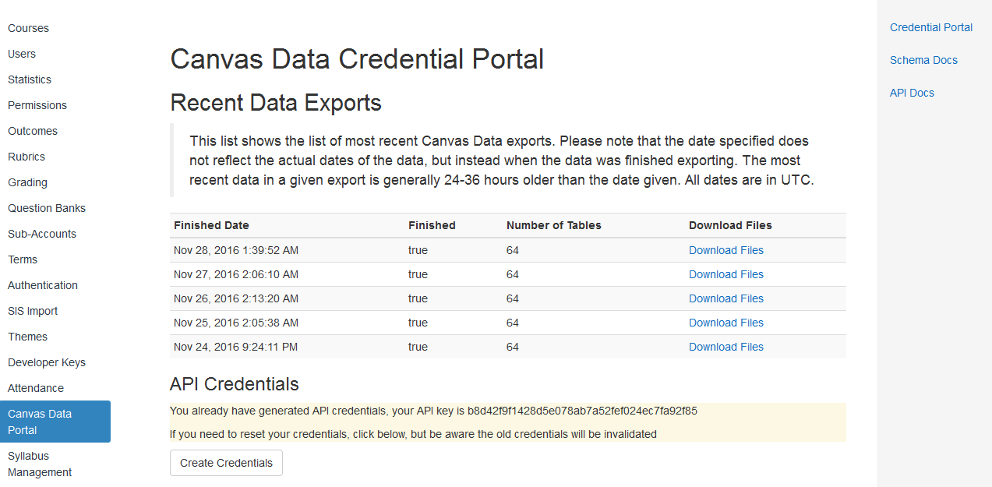



Each file contains data for the table which is formatted as tab delimited .txt flat file. The flat file is zipped with a file extension of .gz.

### **Canvas Data API**

Canvas provides API to automate the process of downloading the files from Canvas Data Portal.

API details can be found in:

<https://portal.inshosteddata.com/docs/api>

If API is used, there will be a need to figure out how to store the data in the database / data warehouse from text flat files.

Options can be:

1. Create 60+ tables in the database
2. Figure out a way to automatically delete data from the tables and insert new data from tab delimited flat files into the tables.

Cons:

1. A lot of tables will be added to the database if we will store all 60+ tables.
2. May take hours to re-populate tables daily because data are from the start of LMS implementation and will grow in the future.

Other Options:

1. Only select certain or a few tables that the institution will need, so there is no need to re-populate all 60+ tables.

### **Amazon Redshift**

Pricing: Y1 - $12,250; Y2 - $12,500; y3 - $14,500

I believe this option is if the institution does not have their own data warehouse and is considering using Amazon RedShift as a data warehouse for Canvas data.

According to Jason Rock, a representative from Canvas, “Amazon Redshift is a yearly subscription offering. With Redshift, your flat files are given headers for easier manipulation of data. Also, you get data dating back to the beginning of your subscription”.

**Access to Hosted Data in RedShift**

[Canvas Data files](https://guides.instructure.com/m/4214/l/449109?data-resolve-url=true&data-manual-id=4214) can be used to create visual analysis using queries and reports in ODBC analytics tools. Common tools include Excel (using Amazon Redshift), Tableau, R, and SQL Workbench/J. Most other ODBC and Java database connectivity (JDBC) PostgresSQL clients should support the data, but pgAdmin is not supported. (Reference: <https://guides.instructure.com/m/4214/l/449098-what-is-canvas-data>)

**Tableau**

Based on a Canvas consultant, if using tools such as Tableau, there is no need to go with Redshift option. Instructure offers services that link existing Tableau (or maybe other tools) environment with Canvas Data. As part of the project, we can select up to ten predefined reports from their resource library. We can also embed the Tableau environment directly into Canvas. Optionally, we can choose to have them create up to th**ree** custom reports for us or invite them onsite so they can work directly with our team.

Pricing:

**Configuration *plus* Standard Reports $1,500**

• Configuration of Tableau to use Canvas Data as a data source.

• Select up to 10 pre-defined reports from our resource library to be loaded into Tableau.

• Embedding Tableau environment* directly into your Canvas instance.

• Knowledge transfer to provide basic understanding of configuration, architecture, and report

**usage.**

**Configuration *plus* Custom Reports $4,500**

• Configuration of Tableau to use Canvas Data as a data source.

• Embedding Tableau environment* directly into your Canvas instance.

• Select up to 10 pre-defined reports from our resource library to be loaded into Tableau.

• Up to three custom reports created from Canvas Data** and loaded into Tableau

• Knowledge transfer to provide basic understanding of configuration, architecture, and report

usage.

**Onsite Workshop *plus* Reporting $11,500**

• Up to two days of consultation with a Canvas Data expert.

• Configuration of Tableau to use Canvas Data as a data source.

• Embedding Tableau environment* directly into your Canvas instance.

• Select up to 10 pre-defined reports from our resource library to be loaded into Tableau.

• Up to three custom reports created from Canvas Data** and loaded into Tableau.

• Includes onsite workshop, Tableau configuration, custom report creation, and knowledge

transfer.

*

A sample video of how to use Tableau with hosted data can be found here:

<https://community.canvaslms.com/videos/1221>